SNOW CONES

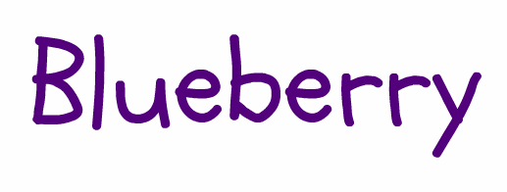

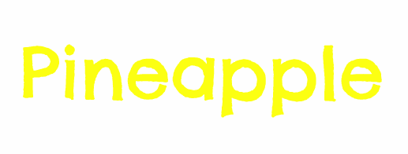
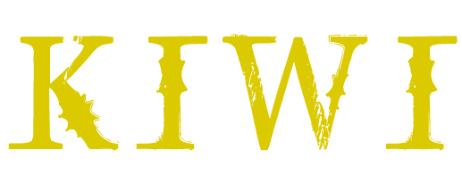
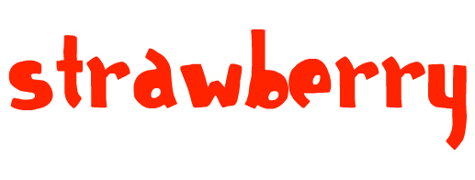

You can print and laminate
these 2 pages
(right-click some flavors, click cut)

See label designs below.

You can print the following in A4 sticker papers or photo-stickers.

Page 5 is ASSORTED
6 = STRAWBERRY
7 = BUBBLE GUM
8 = GREEN APPLE
9 = LYCHEE
10 = ORANGE*
11 = KIWI
12 = TIGER’S BLOOD
13 = GRAPE*
14 = WATERMELON
15 = PINEAPPLE
16 = BLUEBERRY

*New flavors coming this April

Kiel’s Special Offer, 2013
Enjoy a P200 rebate by just emailing us 3 pictures:
1 picture of
you at your snow cone business
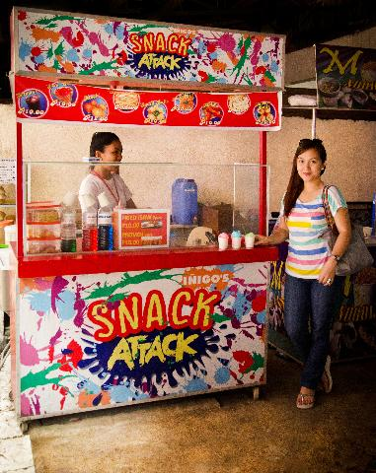
Example:

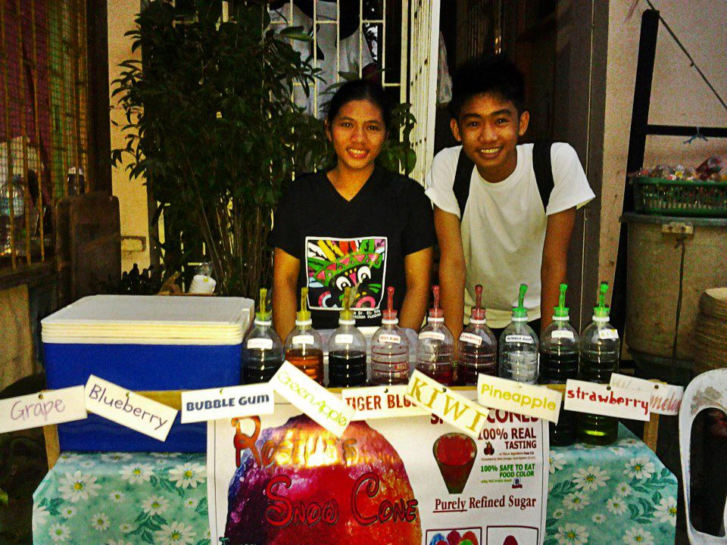

+ 1 picture of 8 or more people (any age) falling in line at your snow cone business similar to the following:
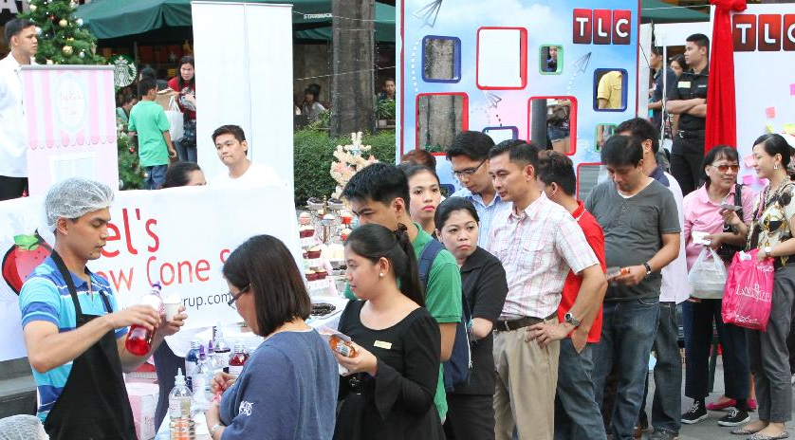

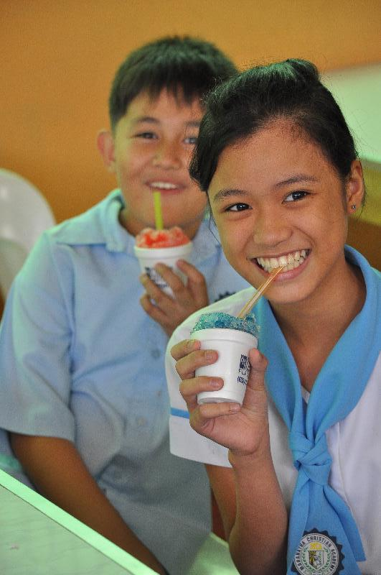
+ 1 picture of people (any age) enjoying snow cones:

Everyone SMILE!
Send pictures to: SnowConeSupply@gmail.com

Then text Kiel
0917 804 7747
(Choose where to claim:
any LBC, Cebuana, ML, or Palawan branch)

We will add your pictures to www.kielsyrup.com as featured customers.
Thanks and God bless!

